**Alekhya Krishna Balivada Azure Databricks Assessment-3 (30-12-2023)**

**Creating the Visualization:**

**Step-1:** Create a cluster in the existing databricks resourse “azddatabbiba_Hexaware”.

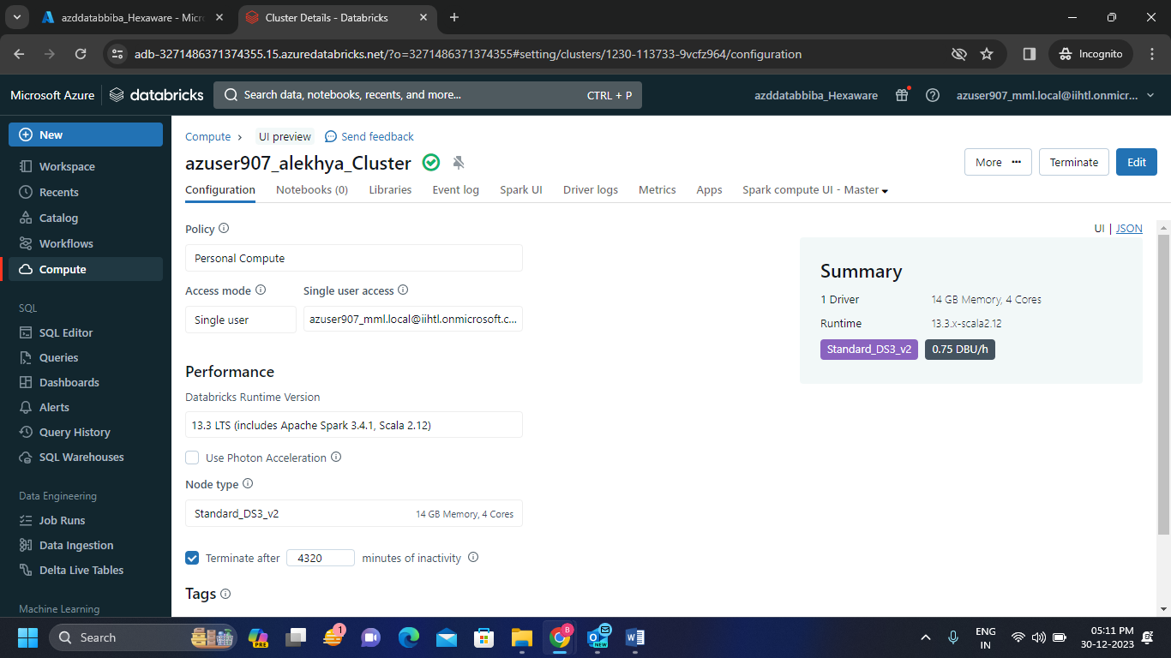

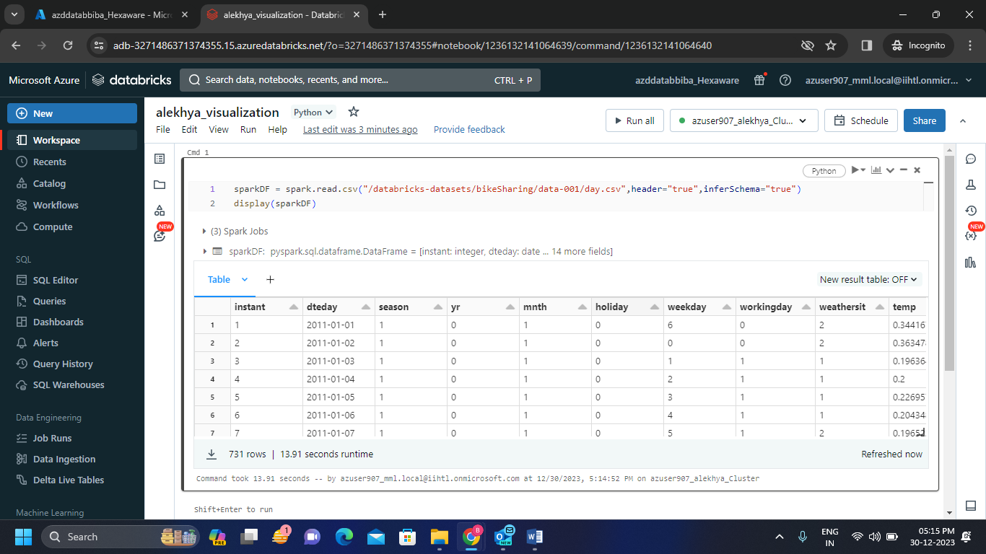**Step-2:** Create a notebook just like below and run a code inside the notebook.

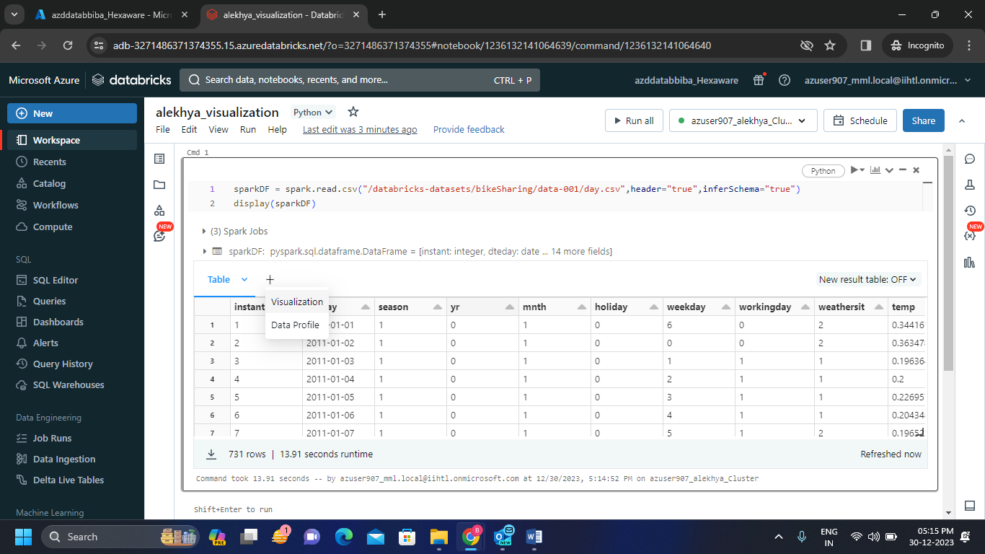**Step-3:** Click on the + just next to the result table then click on the visualization to check the data graphically.

* 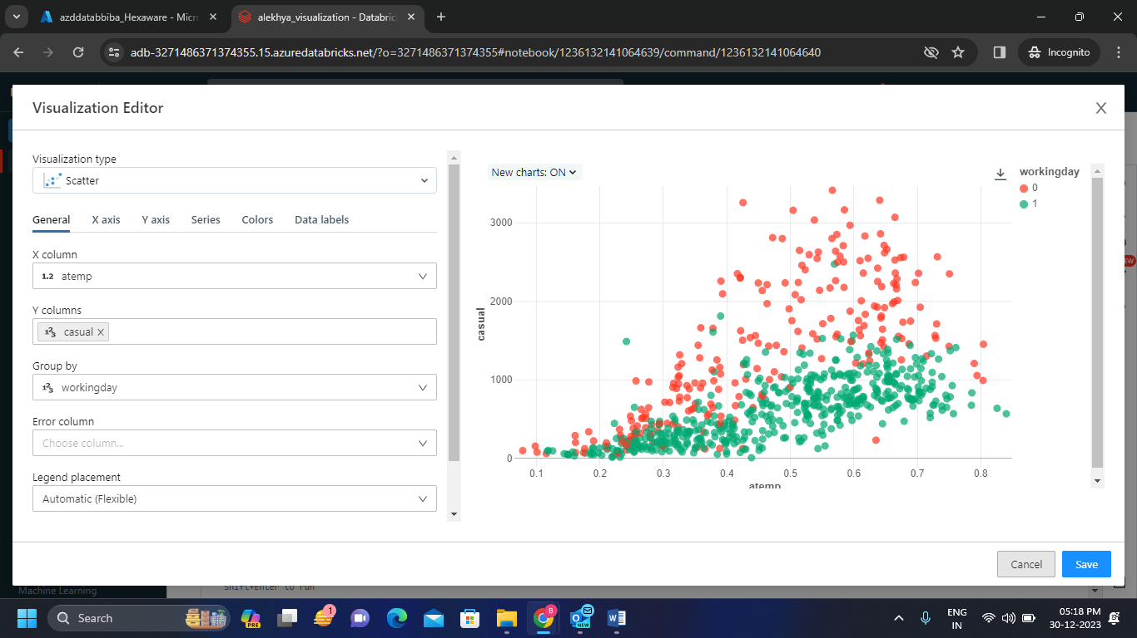We have to fill the data in the visualization editor as per our requirement we get the chart as below. We can change the colours by going to colours bar.
* 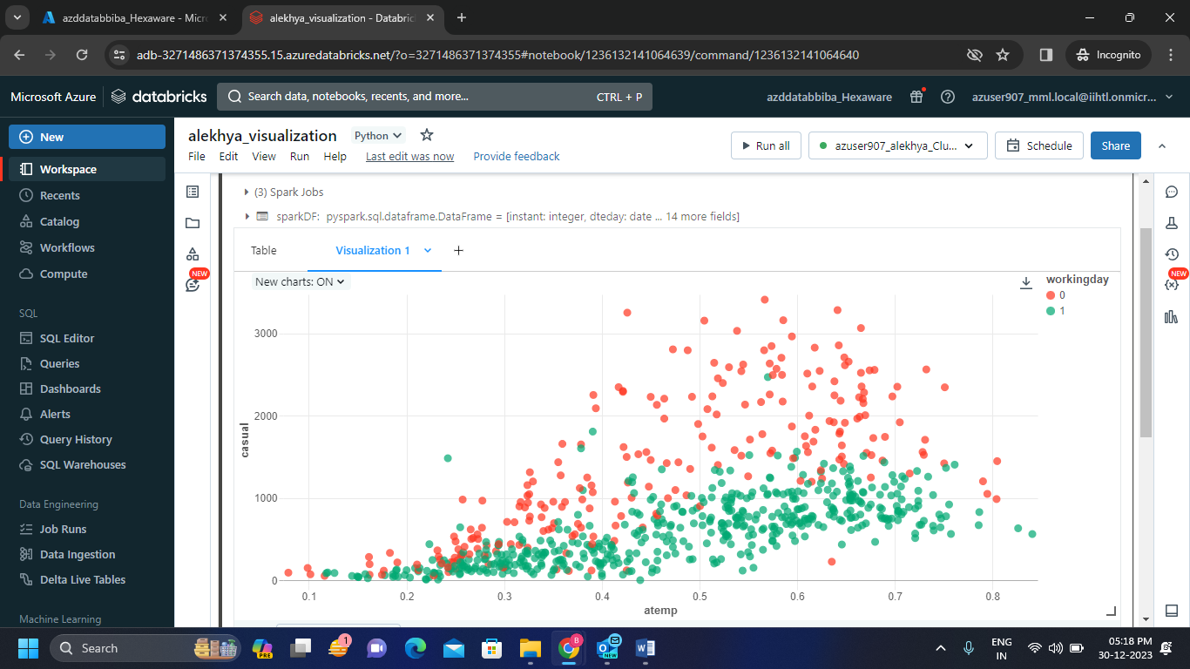We have to save the visualization so that we can get the visualization in the result bar.
* We can download the visualization too.

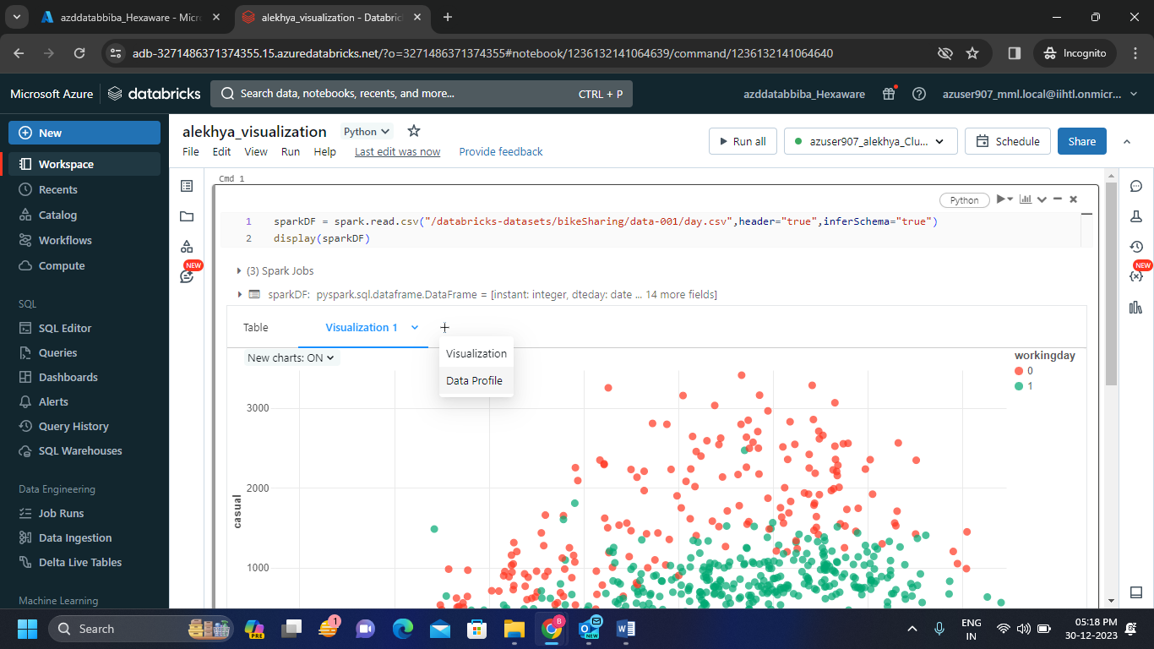**Step-4:** Now we can create the data profile by clicking on the + just like we created visualization.

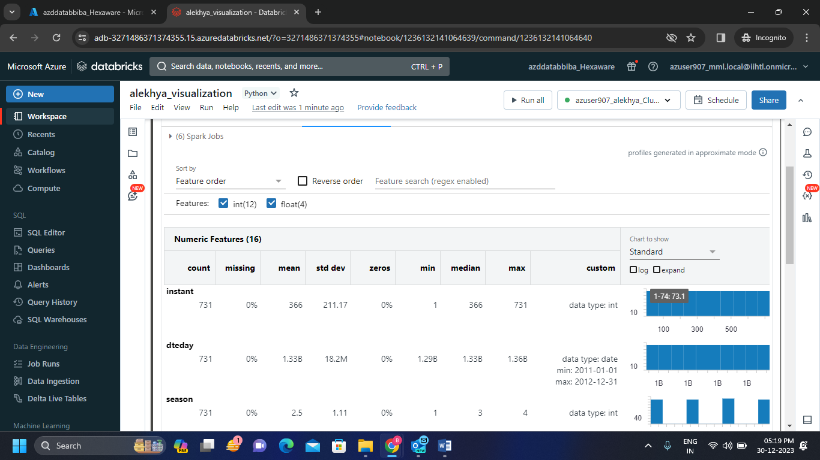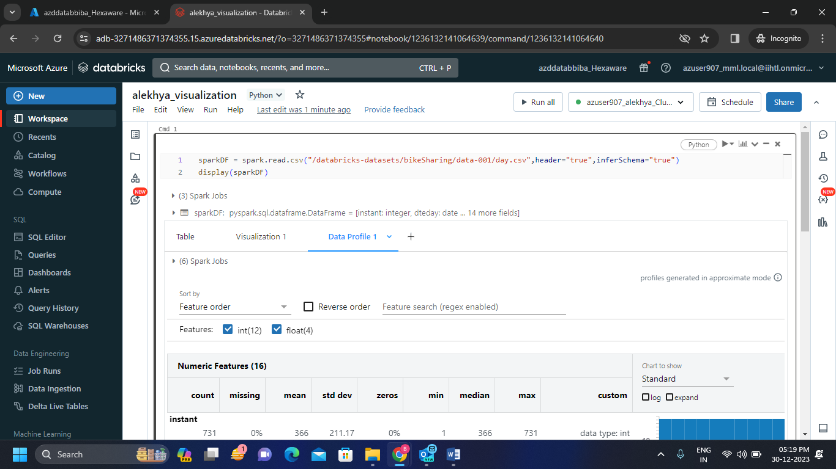**Step-5:**  We created the data profile for the code we ran.

